Tutorial 18

Programming exercise 1 – MyForms
- Add new class to WIUT project, call it MyForms
- Add the following code to MyForms class

public static T GetForm<T>() where T : Form, new()
{
return Application.OpenForms.OfType<T>().FirstOrDefault() ?? new T();
}
This code is using some advanced .Net concepts. You may want to do some research on the topic of “generic parameters” and “generic parameters constraint”

Programming exercise 2 – Applicants list form
- Add new form. Name it ApplicantListForm.
- Set Text property of the form to Applicants
- Add DataGridView control. Name it dgv. Set the following properties:
  - ReadOnly = true
  - AllowUserToAddRows = false
  - AllowUserToDeleteRows = false
  - AllowUserToOrderColumns = false
  - SelectionMode = FullRowSelect
- Add 4 buttons – Add, Edit, Delete, Refresh
- Add a combobox and a button to facilitate sorting
- Add a combobox, textbox and a button to facilitate searching
- Use Anchor property of the controls to enable proper resizing of the form
- Add code in form load event of ApplicantListForm
MdiParent = MyForms.GetForm<ParentForm>();

- Add code for “All applicants” menu item in ParentForm
MyForms.GetForm<ApplicantListForm>().Show();

- Run the program and see the result

IMPORTANT!!! Before doing the next step ensure that you have no errors and compile your project at least once. Running the project with Start/F5 is causing recompilation, so if you can run it with F5 and see no build errors, you are good to go on.

- Return to ApplicantListForm, click on the smart tag button in the corner of the grid and add Applicant class as a new Object Data Source:

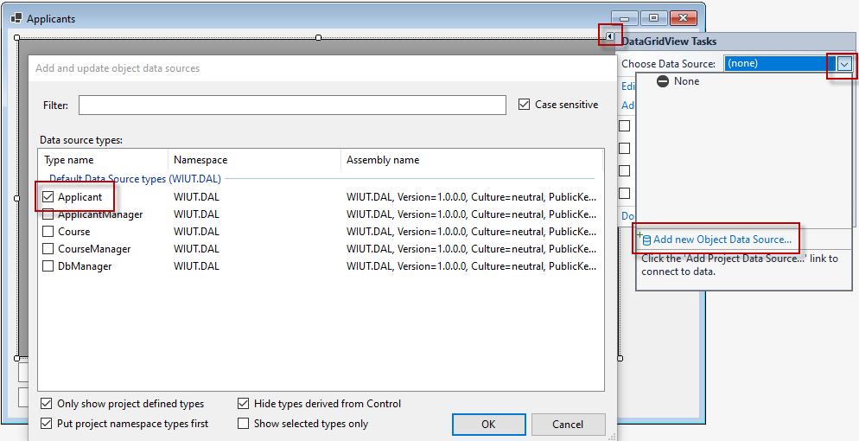
- Set up the grid to be bound to newly created object data source.
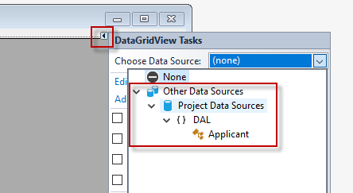

- Create a new function inside ApplicantListForm
private void LoadData()
{
dgv.DataMember = "";
dgv.DataSource = null;
dgv.DataSource = new ApplicantManager().GetAll();
}

- Call LoadData function from FormLoad event handler and Refresh button
- Populate the database with sample data if needed and run the project
- Add items to sort combobox
Name
Last name
Date of birth
Course
- Add the code to Sort button

private void btnSort_Click(object sender, EventArgs e)
{
if (cbxSort.SelectedIndex < 0)
MessageBox.Show("Select an attribute to sort by");
else
{
ByAttribute selectedAttribute;
if (cbxSort.SelectedIndex == 0)
selectedAttribute = ByAttribute.Name;
else if (cbxSort.SelectedIndex == 1)
selectedAttribute = ByAttribute.Surname;
else if (cbxSort.SelectedIndex == 2)
selectedAttribute = ByAttribute.DoB;
else
selectedAttribute = ByAttribute.Course;

dgv.DataMember = "";
dgv.DataSource = null;
dgv.DataSource = new ApplicantManager().Sort(selectedAttribute);
}
}

- Run the project and see the result
- Add items to search combobox
Name
Last name
- Add code for Search button
private void btnSearch_Click(object sender, EventArgs e)
{
if (cbxSearch.SelectedIndex < 0)
MessageBox.Show("Select an attribute to search by");
else if (string.IsNullOrWhiteSpace(tbxSearch.Text))
MessageBox.Show("Provide the search term");
else
{
var selectedAttribute = cbxSearch.SelectedIndex == 0 ? ByAttribute.Name : ByAttribute.Surname;

dgv.DataMember = "";
dgv.DataSource = null;
dgv.DataSource = new ApplicantManager().Search(tbxSearch.Text, selectedAttribute);
}
}
- Add override for ToSting() function in Course class to return Name property
public override string ToString()
{
return Name;
}

- Run the project and see the result

Programming exercise 3 – Course list form
Independent task – create course list form

